1-Page Summary Report: Hypothesis Testing with R — Familiar Packs

Problem Statement
Familiar, a blood-transfusion subscription startup, needs statistically defensible answers to two questions: (1) Does the basic Vein Pack produce a mean subscriber lifespan significantly different from the general-population benchmark of 71 years? (2) Do Vein Pack and the premium Artery Pack differ in mean lifespan? Clear answers will underwrite marketing claims and guide product positioning while controlling Type I error risk.

Solution Strategy
1. Load and inspect the 40-row lifespan CSV (20 Vein, 20 Artery).
2. Formulate explicit null and alternative hypotheses for both questions.
3. Verify approximate normality and SD-ratio ≈ 1 (assumptions for t-tests).
4. One-sample t-test of Vein lifespans against μ₀ = 71.
5. Two-sample (Welch) t-test comparing Vein vs Artery.
6. Quantify practical importance with Cohen’s d and 95 % CIs; run a small Monte-Carlo power simulation.
7. Communicate results in layered language (executive headline → product recommendation → technical diagnostics) following the audience-analysis principles in the supplied PDFs.

Solution
Vein Pack mean = 76.17 years (SD = 1.93, n = 20). One-sample t-test vs 71: t(19) = 11.96, p = 2.75 × 10⁻¹⁰, 95 % CI [75.26, 77.07]. Extremely strong evidence of a longevity benefit relative to the population benchmark.
Artery Pack mean = 74.87 years (SD = 2.21). Two-sample Welch t-test: t ≈ 1.97, df ≈ 37.3, p = 0.056. The observed 1.30-year advantage for Vein is not statistically significant at the conventional α = 0.05; the 95 % CI for the difference includes zero. Cohen’s d ≈ 0.62 (medium). Power analysis shows that roughly 40–45 subscribers per pack would be required to detect a 1.3-year difference with 80 % power.
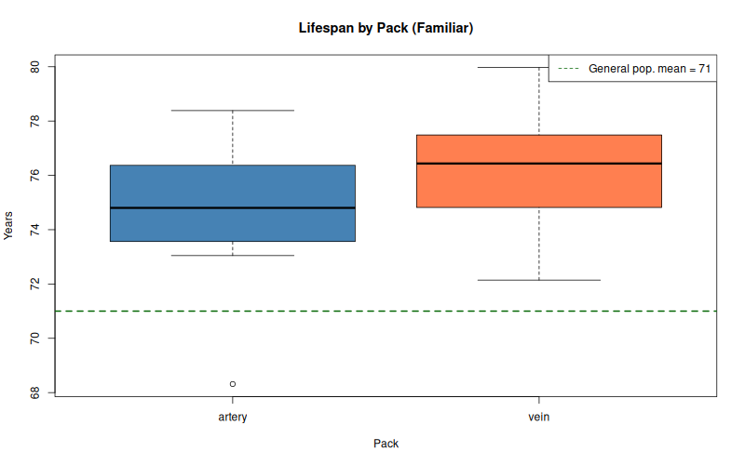
Lifespan by pack with 71-year reference line
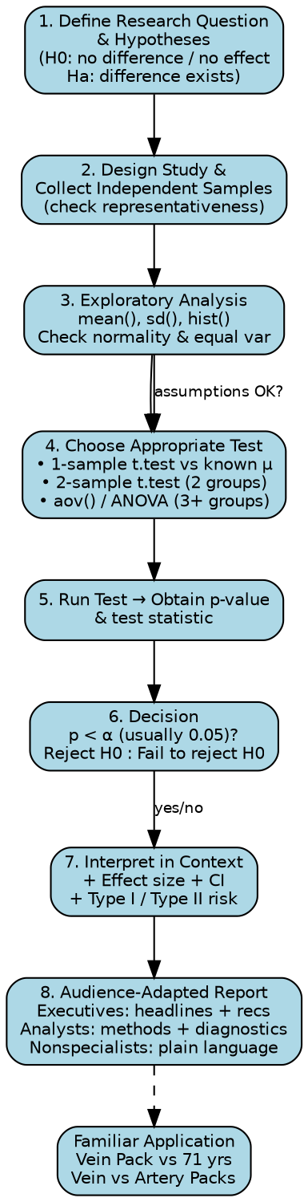
End-to-end hypothesis-testing workflow

Key Takeaways
1. Marketing can confidently claim a statistically robust longevity benefit for the Vein Pack versus the 71-year general-population mean.
2. The Vein-versus-Artery comparison is promising (medium effect) but currently inconclusive; avoid absolute superiority language until sample size is increased.
3. Always pair p-values with effect sizes, confidence intervals and a power statement; this satisfies both technical reviewers and decision-makers.
4. Audience adaptation is essential: executives need the two-sentence headline; product teams need the recommendation and next-step sample-size target; statisticians need the full diagnostic trail.

